
NOTE: This is an official document by Indexademics. Unless otherwise stated, this document may not be accredited to individuals or groups other than the club IDX, nor should this document be distributed, sold, or modified for personal use in any way.
IDX G9 ENGLISH H+ STUDY GUIDE ISSUE 8
By Maggie Tang, Edited by Ava Sun

- What should I pay attention when I look at graphic novels?
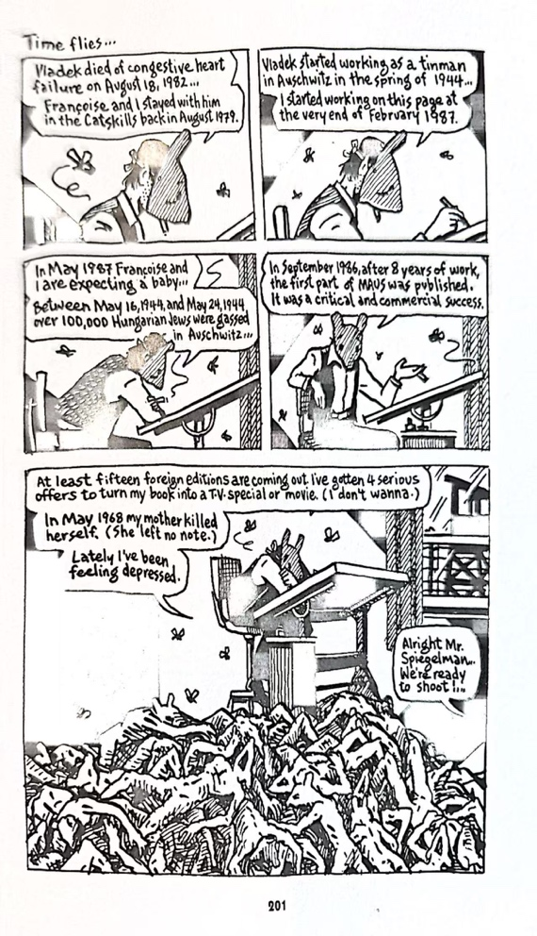
Consider composition first. Usually, graphic novels use powerful composition to balance out their storytelling so that it’s more impactful. Or else, consider movement within the panels. From what view are we looking at? How does the “camera” move?
This page from Maus on the left is a good example. We start with Art Spiegelman drawing, with flies swirling around him, but we’re not really sure why. The main focus in these first four panels is his deteriorating mental state and how he is overwhelmed by the workload coming from Maus I’s publication. The panels still gradually pan out and move downwards, where we get an impactful panel of Spiegelman and the dead bodies. Composition is also cleverly used here with the imbalance of Spiegelman and the bodies. The bodies take up half of the panel, which emphasizes their presence. More than that, in general, the raggedly drawn bodies make this page the more horrific to look at.
- How do I take into account graphic weight?
If you want to study graphic weight, Persepolis is your best shot. There are several panels that utilize graphic weight to show oppression. For one, you could mention how the veils that women wore were pitch black in the graphic novel. In a lot of her panels, Satrapi uses the black veils of these women to show how the veil oppressed her individuality and identity as a woman. Other than Persepolis, the Batman comic shows graphic weight as well:
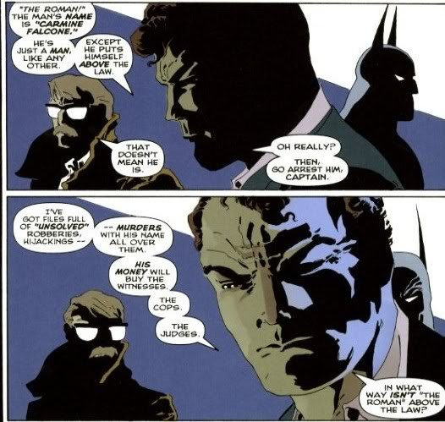
I’m guessing based on composition that the guy in the closeup is Bruce Wayne. Here, graphic weight is used to 3D-ify Bruce Wayne’s countenance. If you want to sound even more smart, you can analyze the cold colors on his right face and (slightly) warmer colors on his left. The strong use of graphic weight in this panel portrays Bruce as a mysterious person, and also shows that he’s being very serious in this panel. It’s also quite interesting that Jim Gordon, the officer on the left (Not completely sure, I don’t read DC) turns his head so he loses more of his facial features. He’s left in the dark. That forces our attention to center on Bruce’s complex expression as he explains that Gordon is underestimating the Joker’s (I think?) ability to evade the law.

- How do you combine text and visuals to do an analysis?
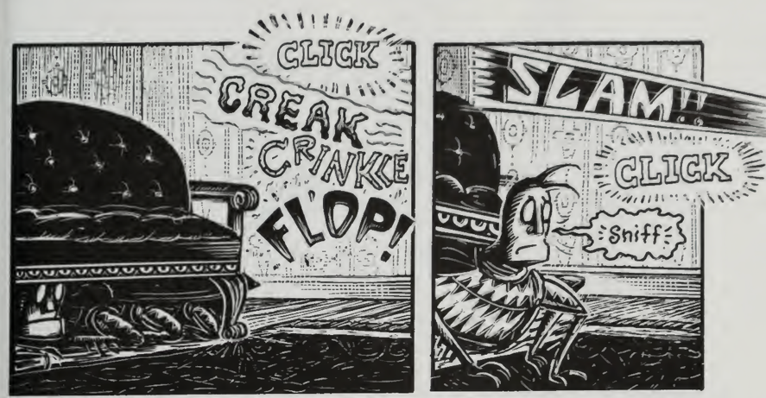
For practice, I recommend using the Metamorphosis graphic novel, since that novel uses a lot of text and visuals combination.
These two panels here are interesting in that Peter Kuper draws these examples onomatopoeia to indicate what’s happening. We can easily tell that Grete is coming through the door like this: She slowly opens the door to check if Gregor’s still out there, then grabs the newspaper that’s holding Gregor’s food and throws it on the floor immediately. That is then followed by her slamming the door and locking it up again. We can easily tell from this combination of text and visual choices that Grete is still terrified and repulsed of her brother and can’t stand the sight of him. Therefore, look out for examples like this.

